User Interface

We created a storyboard of the user interface. These are the two screens that we are going to have:

Main screen:

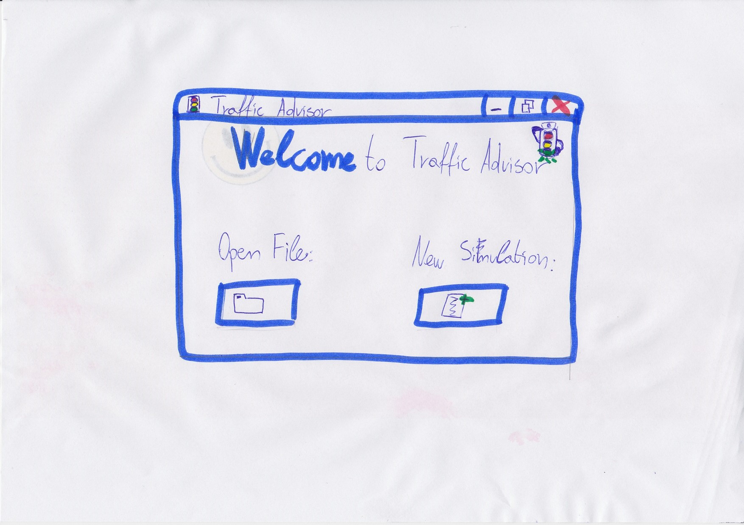

With ‘Open File’ button you can open a simulation file from your PC.

With ‘New Simulation’ button you can start new simulation on your PC.

Project-grid screen:

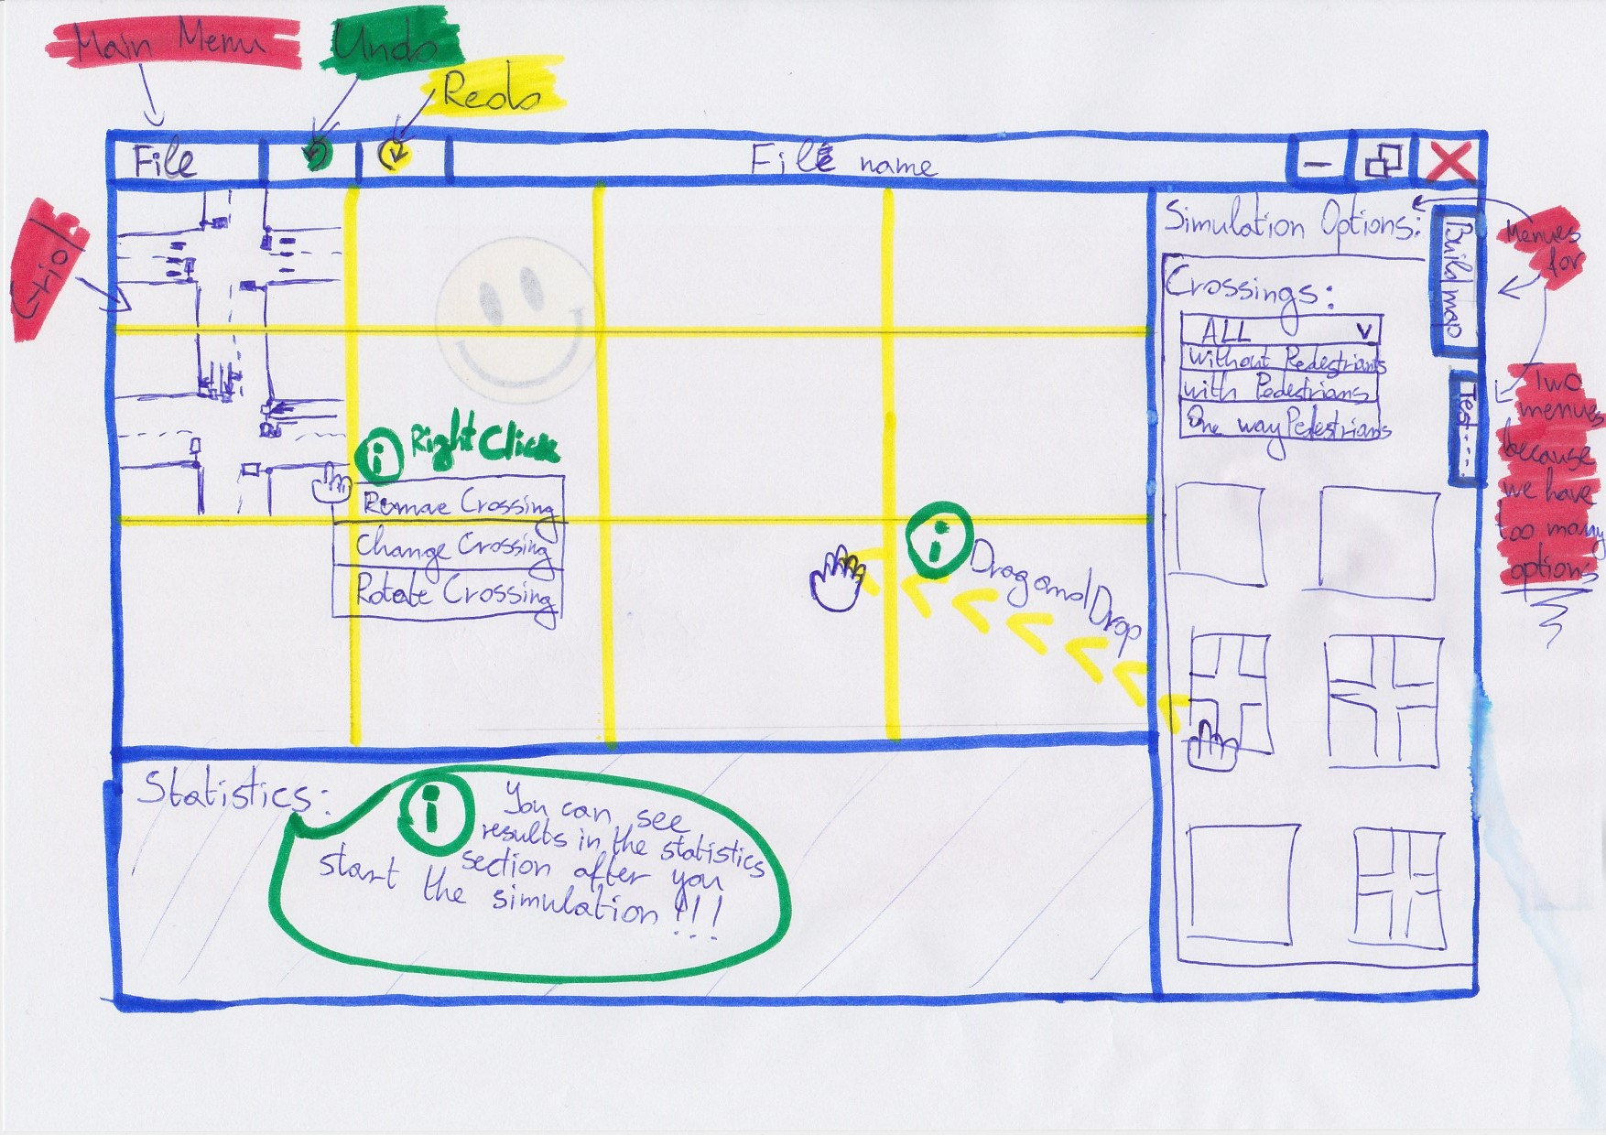

On this screen is the main functionality of the application, we could choose from a lot of options, so we made another look of this form so you could see the rest of the options.

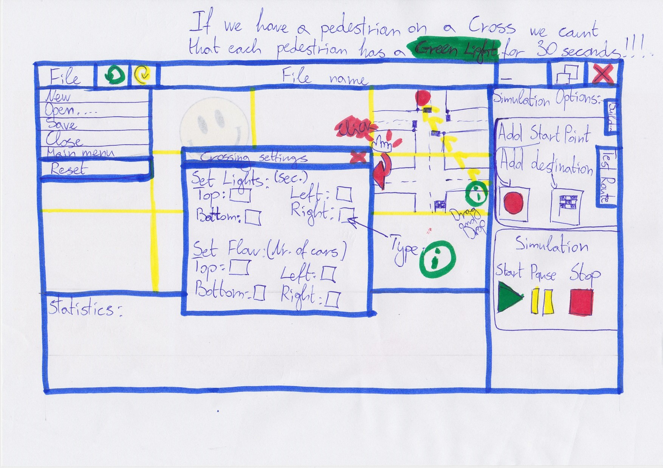

Non-functional Requirements

* The application will be programmed in C#, which means Windows operation system version windows 7 or windows 8 are the required environments for it.
* The application can run on a basic computer.
* You do not need Internet to use our application.
* When a Cross is rotated all its data will be reset.
* If there is a pedestrian on a Cross the system counts that each pedestrian has a Green Light for 30 seconds.
* Results in the statistics section will appear on the screen after the simulation is started.
* Simulation will not start if a ‘Start Point’ and ‘Destination’ points are not chosen.
* Simulation will not start if there are not at least two Crosses on the grid.
* You could not put Cross on the grid if in that place you already have a placed Cross.
* You could add a Cross to the grid by selecting it by clicking on it and then dragging it through the grid and dropping it inside of it.